**Please list complete First, Middle and Last name, and Social Security Number for Background Check purposes. *(Background checks will ONLY be run as the last step of hiring and will be kept confidential)***

**FULL LEGAL NAME:**

**SOCIAL SECURITY NUMBER:**

**The staff positions at BCC require long hours, lifting, walking, standing …. Would this be a problem for you?**

**What position are you applying for at BCC?**

**How did you hear about Beartooth Christian Camp (BCC)?**

**Home Church:**

Updated 1/24

BEARTOOTH CHRISTIAN CAMP

SUMMER STAFF APPLICATION 2024

PAGE 1

**Name:**

**Phone:**

**Mailing Address:**

**Email:**

**Dates of Employment: *(mm/yyyy — mm/yyyy)***

**Position:**

**Organization Name:**

**JOB #1**

**WORK EXPERIENCE**

**If you have answered yes to any of the previous questions, please explain.**

**NO**

**YES**

**Have you ever been convicted of a felony, or do you have any pending charges?**

**NO**

**YES**

**Have you ever been arrested or accused of child abuse, sexual abuse, or sexual harassment?**

BEARTOOTH CHRISTIAN CAMP

Updated 1/24

PAST WORK/LIFE EXPERIENCE

**Have you ever been convicted of a crime involving children or youth?**

**YES**

**NO**

PAGE 2

**Dates of Employment: *(mm/yyyy — mm/yyyy)***

**Position:**

**Organization Name:**

**JOB #3**

**Dates of Employment: *(mm/yyyy — mm/yyyy)***

**Position:**

**Organization Name:**

**JOB #2**

Updated 1/24

PAST WORK/LIFE EXPERIENCE

BEARTOOTH CHRISTIAN CAMP

PAGE 3

TESTIMONY

Updated 1/24

BEARTOOTH CHRISTIAN CAMP

**Please share your salvation testimony. How did you come to know the Lord?**

PAGE 4

SPIRITUAL WALK

Updated 1/24

BEARTOOTH CHRISTIAN CAMP

**Please share how you have been growing in your spiritual walk. What passage of Scripture or verse have you been reading, studying, or memorizing lately that has shaped your faith?**

**The gospel is the good news of Jesus Christ! If you were to share this good news with someone, what would you tell them it is? Feel free to use Scripture!**

**Can you describe a time when you shared this good news with someone else? How did it go? What kind of experience was it? What did you learn?**

PAGE 5

A FEW MORE QUESTIONS

Updated 1/24

BEARTOOTH CHRISTIAN CAMP

**Please describe a time when you had a conflict with a friend, employer, or authority (teacher, parent, coach, etc.). What was the conflict? Who was involved? What did you do? What was the outcome? What did you learn from the situation?**

**What are some of the experiences you’ve had working with children/youth? Please describe your role(s) (examples: church, school, youth clubs, baby-sittings, etc.).**

**Please describe in just a couple sentences why you think you would be a good choice for this position and how you would bring value to the staff at BCC?**

PAGE 6

**Please use as much of the following space as needed and share your heart for why you want to be on the BCC team?**

**RELEASE OF INFORMATION AUTHORIZATION**

1. In connection with my application for this position, I understand that a background report may be requested, paid by BCC.
2. Medical and workers’ compensation information will only be requested in compliance with the Federal Americans with Disabilities Act (ADA) and/or any other applicable state laws.
3. I hereby authorize, without reservation, any law enforcement agency contacted by BCC to furnish the information described in Section 1.

THE FINAL QUESTION

Updated 1/24

BEARTOOTH CHRISTIAN CAMP

PAGE 7

**Name:**

**Company Name:**

**Phone Number:**

**Email:**

**Name:**

**Character/Personal:**

**Pastor/Youth Pastor:**

**Phone Number:**

**Person’s Job Title:**

**Company Name:**

**Email:**

**Phone Number:**

**Company Name:**

**Person’s Job Title:**

**Name:**

REFERENCES

Updated 1/24

BEARTOOTH CHRISTIAN CAMP

PAGE 8

**Professional:**

**Email:**

**Person’s Job Title:**

**Date:**

**Application Signed by:**

**\*\*\*IMPORTANT\*\*\***

BCC’s Development Director, Michelle Patterson, will be following up on all Summer Staff applications, so when you have finished your application, please email it to Michelle at

[**Michelle@beartoothchristiancamp.org**](mailto:Michelle@beartoothchristiancamp.org)

**BACKGROUND CHECK AND AUTHORIZATION**

**Background Check will ONLY be run as the last step in hiring. All information will be kept confidential**

* In connection with my future involvement as a staff member, I understand that Beartooth Christian Camp (BCC) will conduct a background check to determine my ability to minister in this role.
* I understand that if any of the records contain information which is used to deny my employment or volunteer services at BCC, I will be notified of my rights and where I can obtain a copy of the information.

JUST ABOUT DONE

Updated 1/24

BEARTOOTH CHRISTIAN CAMP

PAGE 9

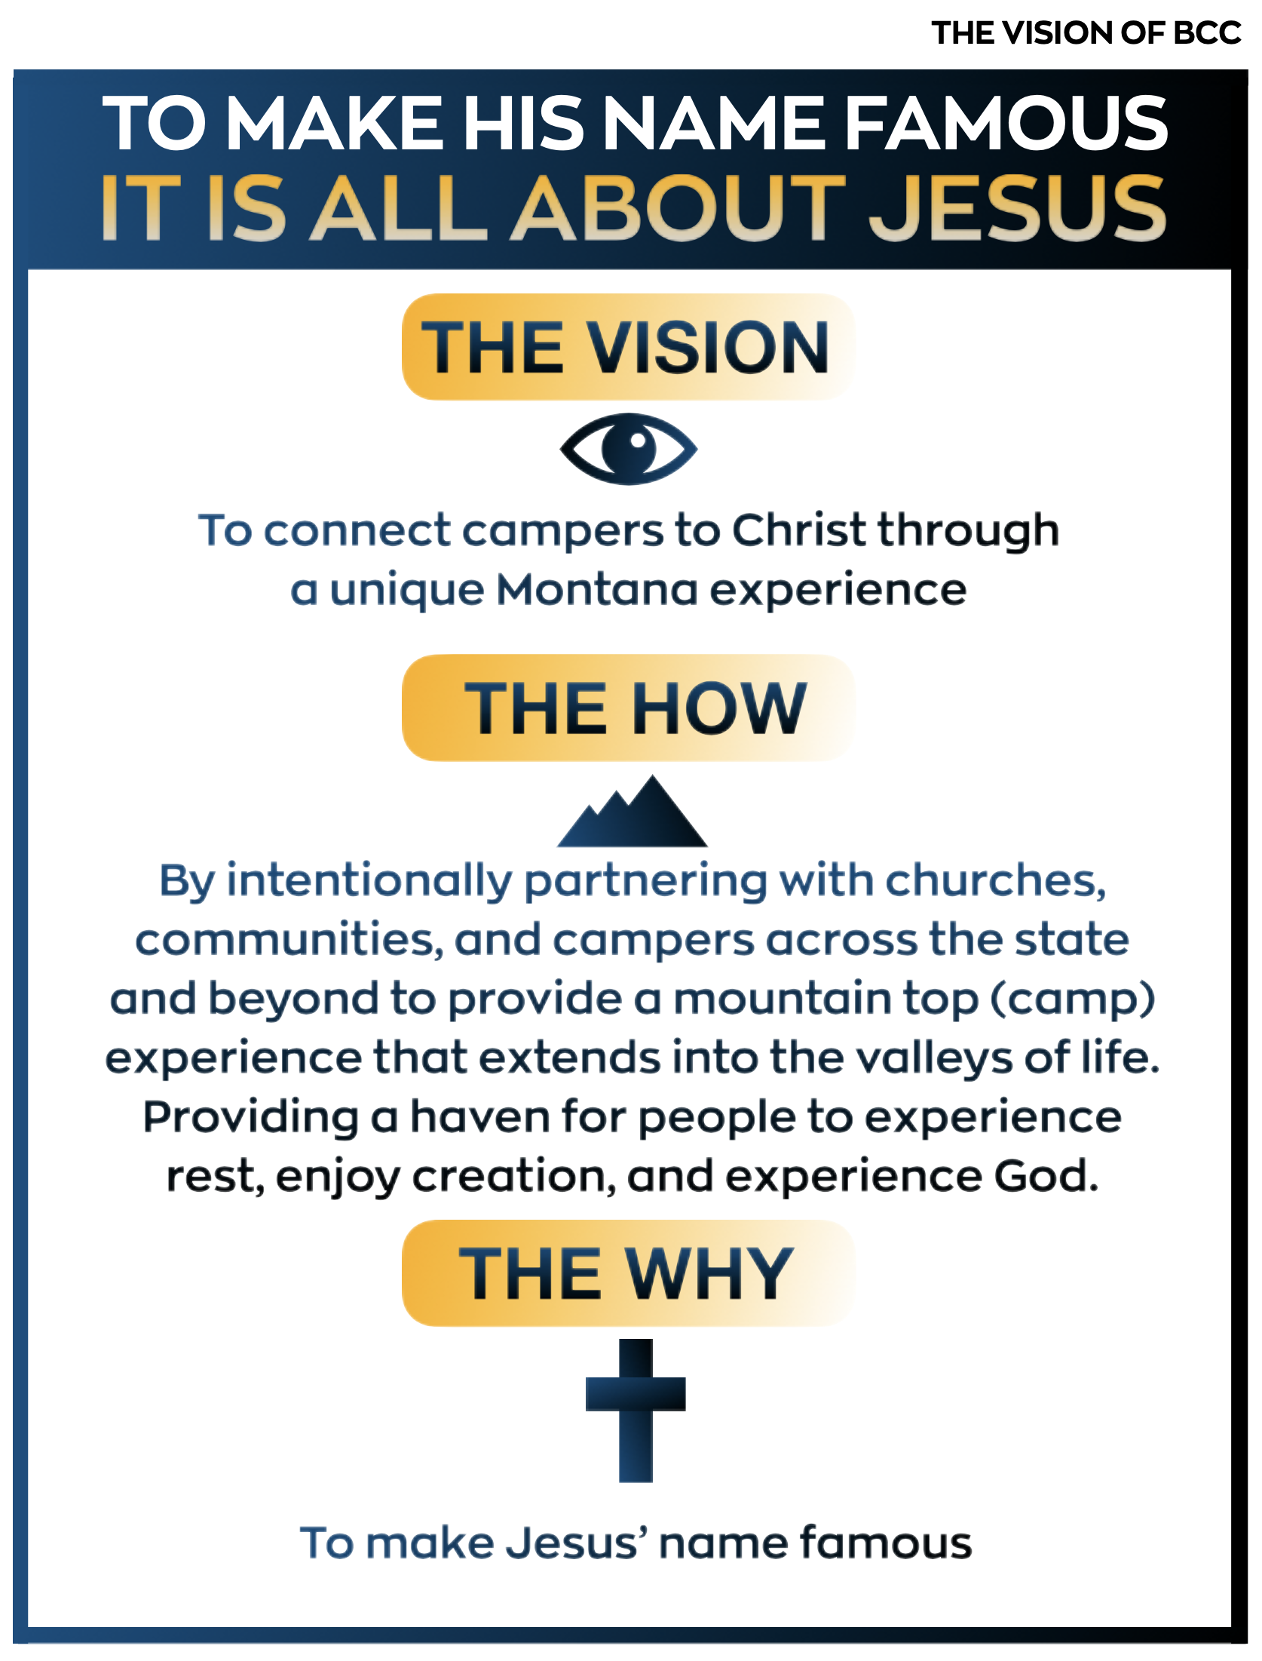

PAGE 10